Currently Used Deprecated Functions Document

# Revision

Version 3

11/15/21 10:13 AM

# SME

Garth Scheidemantel

# Abstract

This document describes the process to document the deprecated functions still in use.

# Group / Owner

Development / Software Developer

# Motivation

This document is motivated by the need to have formal processes in place to track outstanding use of deprecated (unsafe) functions within safety-critical, cyber-physical systems for certification of compliance to standards such as **ISO 21434** and **ISO 26262**.

# License

This work was created by **Motional** and is licensed under the **Creative Commons Attribution-Share Alike (CC4-SA)** License.

[**https://creativecommons.org/licenses/by/4.0/legalcode**](https://creativecommons.org/licenses/by/4.0/legalcode)

# Overview

Many commonly used functions and APIs are not secure in the face of the current threat environment. As these present an ongoing threat to security, they should be replaced with secure alternatives where possible. In order to be able to assess the overall risk presented by their continued use, they should be documented, and their presence justified.

The following diagram illustrates the process to be used:

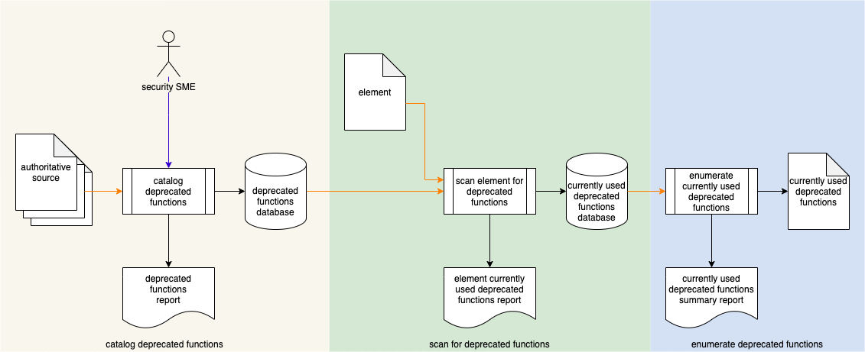

# Process

## Catalog Deprecated Functions

|  |  |
| --- | --- |
| **Inputs** | Authoritative source |
| **Outputs** | Deprecated functions database  Deprecated functions report |
| **Participants** | Security SME |

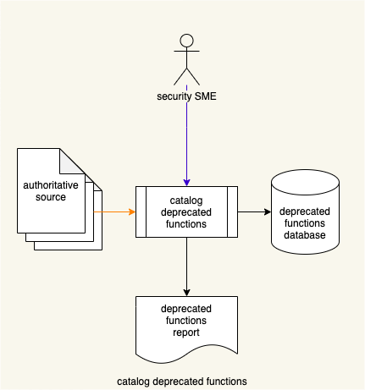

The Security SME reviews the **Authoritative Source** to identify deprecated functions. A **Deprecated Functions Report** is generated.

All identified deprecated functions are entered into the **Deprecated Functions Database**.

## Scan for Deprecated Functions

|  |  |
| --- | --- |
| **Inputs** | Element  Deprecated functions database |
| **Outputs** | Currently used deprecated functions database  Element currently used deprecated functions report |
| **Participants** | **none** |

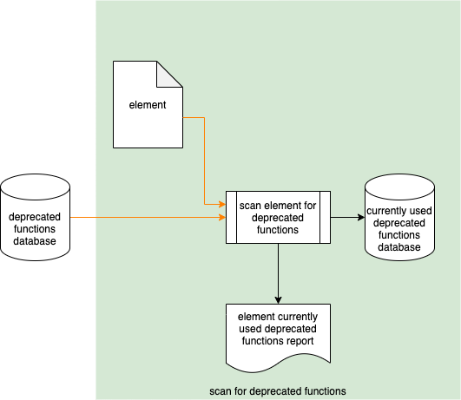

With the **Deprecated Functions Database**, the **Element** is scanned for deprecated functions currently in use. The **Currently Used Deprecated Functions Database** is updated, and a **Currently Used Deprecated Functions Report** is generated.

## Enumerate Deprecated Functions

|  |  |
| --- | --- |
| **Inputs** | Currently used deprecated functions database |
| **Outputs** | Currently used deprecated functions  Currently used deprecated functions summary report |
| **Participants** | **none** |

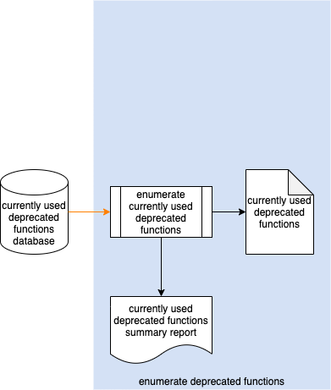

Using information from the **Currently Used Deprecated Functions Database**, the database iterates over the deprecated functions and categorizes them by programming language. A machine-readable **Currently Used Deprecated Functions** list is generated. A human readable **Currently Used Deprecated Functions Summary Report** is also generated from the machine-readable list.

# References

1. **Deprecated Functions Report** (AVCDL tertiary document)
2. **Currently Used Deprecated Functions Report** (AVCDL tertiary document)
3. **Currently Used Deprecated Functions Summary Report** (AVCDL tertiary document)